Garlicky Lemony Humus

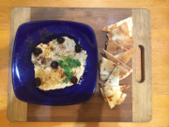

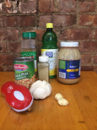
Humus is a staple in our household because of its ease to prepare, its nutritional value and most of all its taste. There are loads of recipes for humus. The two major schools of thought on humus divide on the use of Tahini, the sesame paste that holds the dish together. One school believes that humus is all about chick peas (the primary ingredient) and that the dish should reflect that mild, traditional flavor. The other school says that sesame paste has a rich, beautiful taste, and chick peas are a great, matching vehicle for that flavor. We are adherents to the second school. We also prefer strong tastes so we use lots of garlic and lemon.
Ingredients:
1 can, 16 ozs Chick peas (AKA, garbanzo beans)
3 Tablespoons Tahini (sesame paste)
3 to 4 Tablespoons Lemon juice
2 large cloves Garlic, course chopped
1 teaspoon Cumin
½ teaspoon Cardamom

Tools:
Food processor or blender
or
mortar & pestle

Advice
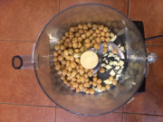
Some folks like their humus really thick and dense to spread on bread. Others prefer a more liquid mixture that is more suited for dipping wedges of pita. We make ours half way between. The way to control the texture is with the liquid from the can of chick peas. When you open the can, save the liquid in a glass. Then use it to thin the humus to taste.

Here is where the instruction get complex!
- chop the garlic, open the can of chick peas and throw them into the food processor.

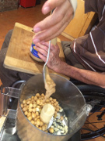
- Add the tahini

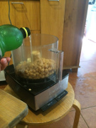

- Add the lemon juice

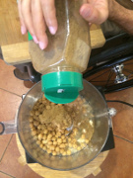

- Add the spices (cumin and cardamom)

Now here is the really hard part:
Turn on the food processor and blend till smooth. That's all. When your mixture is smooth, be sure to taste it. You can add more garlic for spice, more lemon juice for tang or more spices for flavor. You can also add more chick peas or tahini if the taste is too strong.

Finally, check the texture. If you like it thick and dense, leave it alone. If you want a lighter humus, add a little liquid from the can.

The traditional way to serve humus is to spread it into a plate, pour a little olive oil on top, add a few olives and some people sprinkle a little sumac on top (we use paprika). Toast up some pita bread and dip away.

